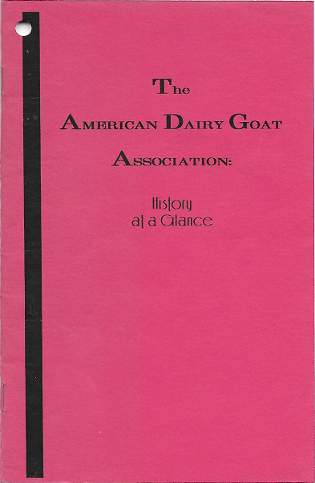
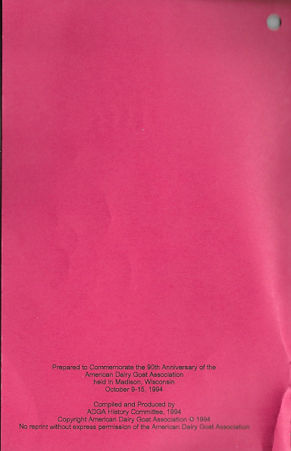

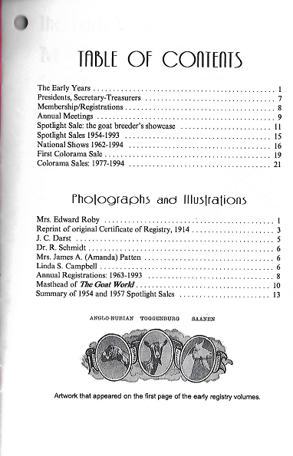



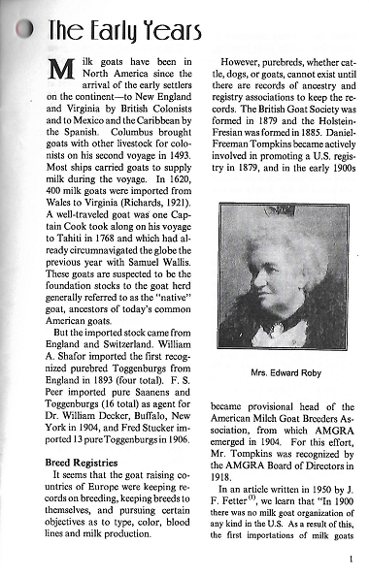

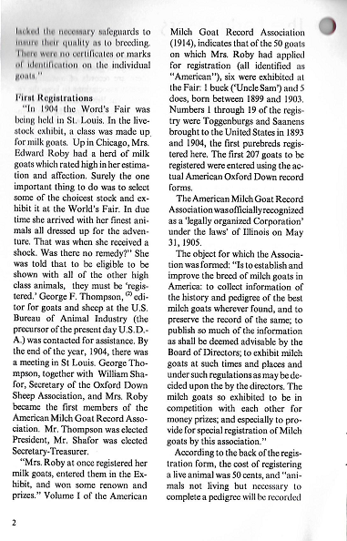

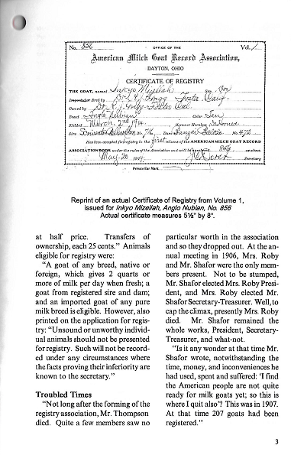

...wrote the Bureau of Animal Industry for information about the milk goat industry. He received a bulletin in which Mr. W. A. Shafor was named Secretary. Mr. Darst lost no time in calling on Mr. Shafor to learn more about milk goats and, incidentally, to purchase some stock. In the meantime, Mr. Shafor proceeded to reveal the whole history of the new organization and its difficulty. Without much ado, he offered to bequeath the whole affair to Mr. Darst, yes, its notoriety, its debts, its work undone, its seemingly last stages of mortal sickness. Mr. Darst agreed to take it as it was."

One of the first acts of Mr. Darst after he became secretary in 1907 was to send out nearly 2000 letters to goatkeepers all over the country, inviting them to join the Association, and to register their stock in it.
Mr. Darst reported that he received answers from over half of the goat breeders contacted.

The Preface to Volume I of the registry says:
"At the ninth annual meeting of the American Milch Goat Record Association the Secretary was authorized to publish Volume I of the Record. The following circular was sent out to all known breeders and owners of Milch Goats, regardless of whether they owned registered goats or not.

Dayton, Ohio
January 1, 1914
Dear Sir:
We are arranging to publish the first volume of our Record of Milch Goats and want to have it accurate. A great many of our Registered Goats are dead, and some of them have not been reported to me. Many have been sold and the ownership changed. Some of those have not been transferred on the Record. We would kindly ask you to cooperate with us and give us what information you can about any registered goats that you now own, or that you did own formerly, and whom you sold to, any that you know to be dead, etc. Always give name of goat and Register number.

We have received many responses that caused a number of corrections to be made, but because some did not respond, we were unable to find out what became of their registered stock. It was intended to have this publication as near accurate as possible and we believe it is; but, because it was not possible to get it accurate you will find mistakes and discrepancies that will probably be corrected by supplementary publication in some reliable monthly from time to time as the facts are obtained.

Our Charter is published in this Volume, for the information of those persons who do not know under what authority we are acting, the reason for, and the continuance of the American Milch Goat Record Association, for the improving of the Milch Goat industry in America.

You will notice that this Association was formed to improve the American Milch Goat, and not to boost any one breed above another, therefore any suggestions to this end are earnestly solicited by the Board of Directors. A Pure Breed Record was desired by some, and action was taken at the ninth annual meeting to this end, and yet not destroy the object of this Association, so we have separated and started a pure breed record, which is herein designated by a separate index.
-4-

What are known and designated as Pure Breeds, all trace their origin through our registration, back to importation from Europe. With best wishes for the improvement of the Milch Goat industry, and the fraternal fellowship of all Milch Goat owners, this Volume is dedicated.
J.C. Darst, Secretary, Dayton, Ohio
Francis King Cooke, President Winnetka, Illinois"

When Volume I was published, it listed 89 members, and almost 900 animals.

"It was not an easy task, and Mr. Darst wanted everything straight and true. He left no clue untraced When he could not be certain about an animal's breeding, then he put the owner on his own dignity.

"In those early years of registry, about the best to be realized was to trace a goat's pedigree to importation. Those were accredited as purebred. It is different now, for registration papers must accompany an imported goat describing its breeding and credits."

In 1922, the 'Milch Goat' in the name of the association was changed to 'Milk Goat'. Sixty years after the registry was formed, in 1965, at the urging of William Turnquist, the name of the association was changed from the American Milk Goat Record Association (AMGRA) to the American Dairy Goat Association (ADGA).

- ﻿﻿﻿﻿From an article by J. F. Fetter, printed in the American Dairy Goat News, July 1950.
- ﻿﻿﻿﻿George Fayette Thompson (1860-1906).

Eleven individual writings are recorded by the Library of Congress.

The major work of interest is: Bureau of Animal Industry, Bulletin #68, "Information Concerning the Milch Goat, " 87 pages, gloss print, with 16 photographs, published in
1905.

-5-

